**Task-3**

Q 1. Get me IP address of a particular domain (guvi.in)

:- Using command : ping guvi.in

IP address : 104.26.5.88

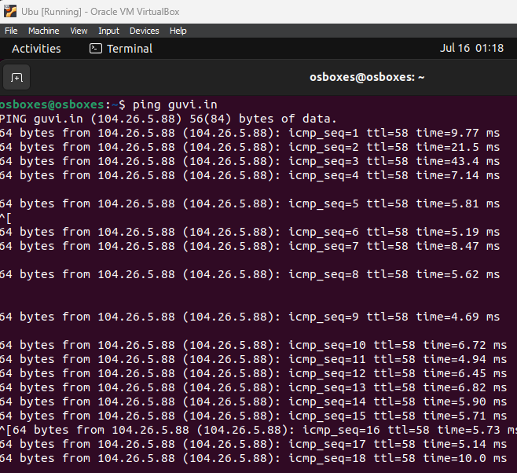

2. How do I find my CPU/memory usage of my server?

To see your CPU and memory usage, you would type the following command into a terminal window:

3. Test the connectivity between 2 nodes?

If the ping command is successful, it will show you the round-trip time (RTT) between your computer and guvi.com. If the ping command is not successful, it will mean that there is no connectivity between your computer and guvi.com.

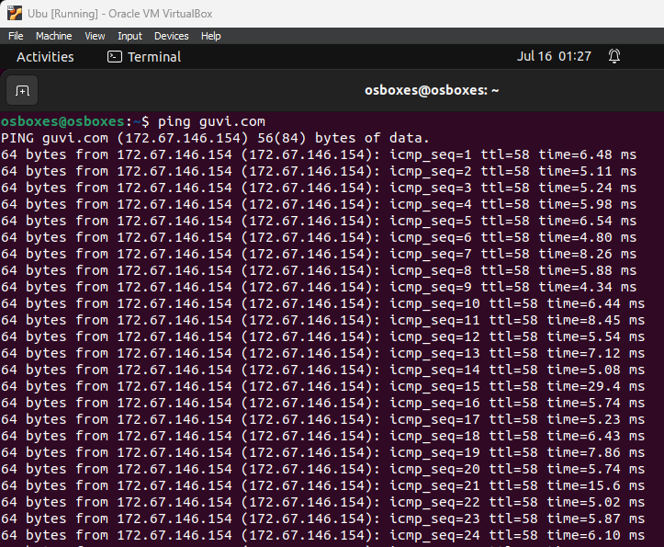

4. I have deployed an application in guvi.com:9000, and logs shows my app is running, but I’m unable to view the page. Check whether my port is open or not ?"

If the netstat command shows a line that says LISTENING next to port 9000, then the port is open. If the netstat command does not show a line that says LISTENING next to port 9000, then the port is closed.



